**CONTAINMENT ZONE ALERTING APPLICATION**

***BACHELOR OF ENGINEERING***

**COMPUTER SCIENCE AND ENGINEERING**

Submitted by

**TEAM MEMBERS:**

**NIVEDHA B**

**TEJASHREE R**

**SOWMIYA A**

**MINIGA M**

**VIVEKANANDHA COLLEGE OF ENGINEERING FOR COLLEGE**

# (Autonomous)

|  |  |
| --- | --- |
| **TEAM ID** | **PNT20200TMID23745** |
| **TITLE** | **CZZAA** |

## 1. INTRODUCTION

1.1 Project Overview

1.2 Purpose

## 2. LITERATURE SURVEY

2.1 Existing problem

2.2 References

2.3 Problem Statement Definition

## 3. IDEATION & PROPOSED SOLUTION

3.1 Empathy Map Canvas

3.2 Ideation & Brainstorming

3.3 Proposed Solution

3.4 Problem Solution fit

## 4. REQUIREMENT ANALYSIS

4.1 Functional requirement

4.2 Non-Functional requirements

## 5. PROJECT DESIGN

5.1 Data Flow Diagrams

5.2 Solution & Technical Architecture

5.3 User Stories

## 6. PROJECT PLANNING & SCHEDULING

6.1 Sprint Planning & Estimation

6.2 Sprint Delivery Schedule

6.3 Reports from JIRA

### 7. CODING & SOLUTIONING (Explain the features added in the project along with code)

7.1 Feature 1

7.2 Feature 2

7.3 Database Schema (if Applicable)

## 8. TESTING

8.1 Test Cases

8.2 User Acceptance Testing

1. **RESULTS**

9.1 Performance Metrics

## 10. ADVANTAGES & DISADVANTAGES 11. CONCLUSION

**12. FUTURE SCOPE 13. APPENDIX** Source Code

GitHub & Project Demo Link

**CHAPTER 1**

## INTRODUCTION

A containment zone alerting application is a mobile application that sends alerts to users when they enter or exit a containment zone. The app uses GPS to track the user's location and sends an alert if the user enters or leaves a containment zone. The app also allows users to set up alerts for specific containment zones.

### 1.1 PROJECT OVERVIEW

The World Health Organization has declared the outbreak of the novel coronavirus, COVID-19 as pandemic across the world. With its alarming surge of affected cases throughout the world, lockdown and awareness (social distancing, use of masks etc) among people are found to be the only means for restricting the community transmission. In a densely populated country like India, it is very difficult to prevent the community transmission even during lockdown without social awareness and precautionary measures taken by the people. Recently, several containment zones had been identified throughout the country and divided into red, orange and green zones, respectively. The red zones indicate the infection hotspot, orange zones denote some infection and green zones indicate an area with no infection. This paper mainly focuses on development of an Android application which can inform people of the COVID-19 containment zones and prevent trespassing into these zones.

**1.2 PURPOSE**

Provide information about containment zones in a particular region by alerting people, through continuous monitoring of an individual's location. This Android application updates the locations of the areas in a Google map which are identified to be the containment zones. The application also notifies the users if they have entered a containment zone and uploads the user’s info to the online database. To achieve all these functionalities, many tools and APIs from Google like Firebase and Geofence are used in this app. Therefore, this application can be used as a tool for creating further social awareness about the arising need of precautionary measures to be taken by the people of India.

**CHAPTER 2**

## LITERATURE SURVEY

### 1. Social Distance Alert System to Control Virus Spread using UWB RTLS incorporate Environments

The author proposed a method to develop a real-time location system (RTLS) based on ultrawideband (UWB) wireless technology that gives the most accurate locations of approximately 11cm using methods like trilateration and TDOA (Time Difference of Arrival). Coordinates of the location can be obtained by installing RTLS in predefined areas which are used to calculate the distance between Mobile UWB Devices (MUD’s). An alert triggered by a system to maintain distance if distance between the employees is less than the prescribed social distance can keep the work premises safe and control the spread of coronavirus. This can be a great solution to control the spread of corona virus. This study can be a great solution to control the spread of virus in corporate working environments which are mostly confined in size and indoor in nature.

### 2. A Detection, Tracking and Alerting System for Covid-19 using Geo-Fencing and Machine Learning

The author proposed a complete Covid-19 Detection, Tracking and Alerting Mobile Application Kit which helps people to defend against Covid-19 spread. This is a first of its kind application that uses Geofencing and Machine learning together to combat the spread of Coronavirus. This app is a threefold app. The first fold is a Detection System for a user to undergo a Symptomatic Quiz based on a Risk Assessment ML Model to detect the presence of Covid in the user's body. The second fold is an efficient Tracking system that uses Geofencing technology to keep track of all the people who come into contact with the user. And the third fold is an Alerting system that sends the alert message to all those people who came into contact with the user if the user is tested as Corona positive. Thus, by using the technology, Geofencing allows to perform contact tracing of potential patients and alerts the possible network of people who might be infected by coronavirus.

### 3. Android Application based Smart Bus Transportation System for Pandemic Situations

Smart Bus Transportation System was introduced which guides the passengers in booking the bus tickets using the Android Application and it also helps the passengers to keep an update on bus location based on their request. This system also sends alert message few minutes in advance to the passengers before the bus reaches the passengers boarding point. This system also sends the precautionary instruction priory the passengers that have to be followed while traveling in the bus. In order to provide additional safety to the passengers the temperature of the passengers is monitored and intimated to the bus in change before they are permitted into the bus.

### 4. Social Distancing Inspection to Mitigate COVID-19 Using K-Nearest Neighbour

In this paper, a model is recommended where the total number of people presenting the frame is detected using the YOLO object detection algorithm, and distance between each individual is measured Using K-Nearest Neighbour. If the distance between any two individual less than 6 feet or 2 meters then a red bounding box pops around them indicating that they are violating the rule of social distancing. This model is implemented on Raspberry Pi with a buzzer system for alert.

### 5. Social Distancing and Face Mask Monitoring System Using Deep Learning Based onCOVID-19 Directive Measures

The author proposed a system consisting of data processing, data augmentation, image classification using mobilenetv2 and object detection. The modules are developed using TensorFlow and open-cv python programming to detect faces with masks. If a person wears a mask they will be in a safe zone and the system shows a green box where if the person doesn't wear a mask, then it will be shown in a red box and with the message of alert as well. Social distancing detection will detect that two or more person in a single frame are walking with maintaining social distancing with at least 2 meters of range with each other using the Euclidean distance method, it will work in a Reliable manner with accurate results during this current situation which will easily help to track the person and collect fine if they violate any government directive guidelines so our system, will prevent the spread of the disease. Every Automation process reduces manual inspection to inspect the people which can be used in public places to control the spread of the virus and this prototype could be used in many places like park, hospital, airports, temples, railway station etc. to control this pandemic situation.

### 6. Application of Face Recognition in Tracing COVID-19 Fever Patients and close Contacts

The author developed a face recognition system to detect patients with fever symptoms and to trace close contacts. A real-time alert is sent to the account manager on a web or mobile app to enable further actions to quarantine the patients and close contacts. The RGB camera is used to detect a face and locate the forehead. The thermal image of the face is used to measure the temperature of the skin in the forehead. A black body is optional to improve the temperature measurement accuracy. After a patient is confirmed, his identification can be recognized using face recognition. By face recognition clustering, all face images of this person in the past given period of time (e.g., 14 days) can be retrieved. Furthermore, close contacts of this patient can also be retrieved from saved frame images or the camera ID and time stamp. The work [2] proposed a similar idea of using face recognition to trace fever patients and close contacts but did not give an algorithm on how to trace them. These retrieved results are displayed in an account console, and a notification is sent to the personnel (account manager) on duty in real time, and safety action can be taken to quarantine the persons, achieving the goals of stopping the virus spreading.

### 2.1 EXISTING SYSTEM

There are a number of applications that exist to alert people of containment zones. One such application is the Aarogya Setu app, which was developed by the Indian government. The app uses GPS to track the location of the user and sends alerts if the user enters a containment zone. Other apps that provide similar functionality include the Covid-19 India app and the Corona Kavach app.

### 2.2 REFERENCES

1. https://ieeexplore.ieee.org/document/9711880

2.https://ieeexplore.ieee.org/document/9432254

3.https://ieeexplore.ieee.org/document/9356316

4.https://ieeexplore.ieee.org/document/9388625

**2.3 PROBLEM STATEMENT DEFINITION**

A problem statement is a concise description of the problem or issues a project seeks to address. The problem statement identifies the current state, the desired future state and any gaps between the two. A problem statement is an important communication tool that can help ensure everyone working on a project knows what the problem they need to address is and why the project is important.

A problem statement is important to a process improvement project because it helps clearly identify the goals of the project and outline the scope of a project. It also helps guide the activities and decisions of the people who are working on the project. The problem statement can help a business or organization gain support and buy-in for a process improvement project.

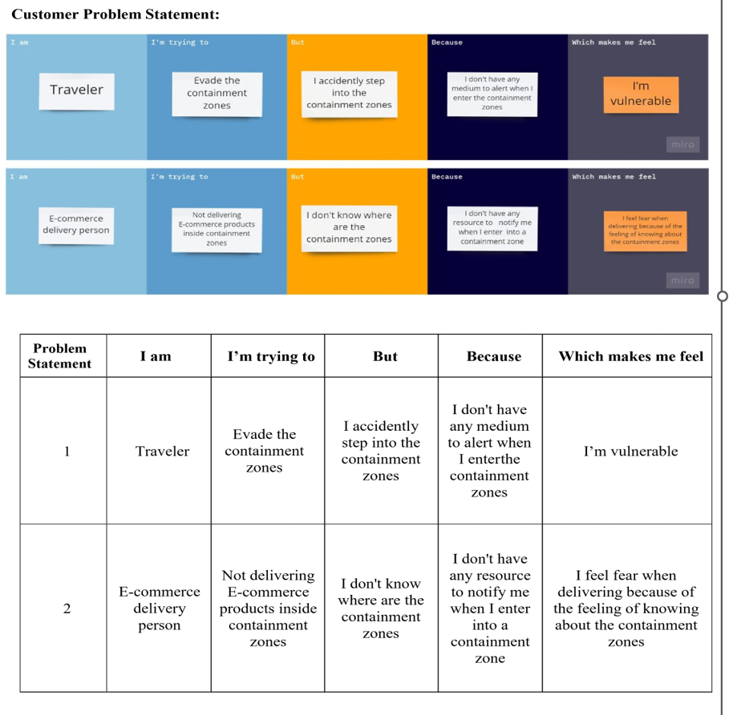

**CHAPTER 3**

## IDEATION & PROPOSED SOLUTION

### 3.1 EMPATHY MAP CANVAS

An empathy map is a simple, easy-to-digest visual that captures knowledge about a user’s behaviours and attitudes. It is a useful tool to helps teams better understand their users. Creating an effective solution requires understanding the true problem and the person who is experiencing it. The exercise of creating the map helps participants consider things from the user’s perspective along with his or her goals and challenges.

## Empathy Map Canvas

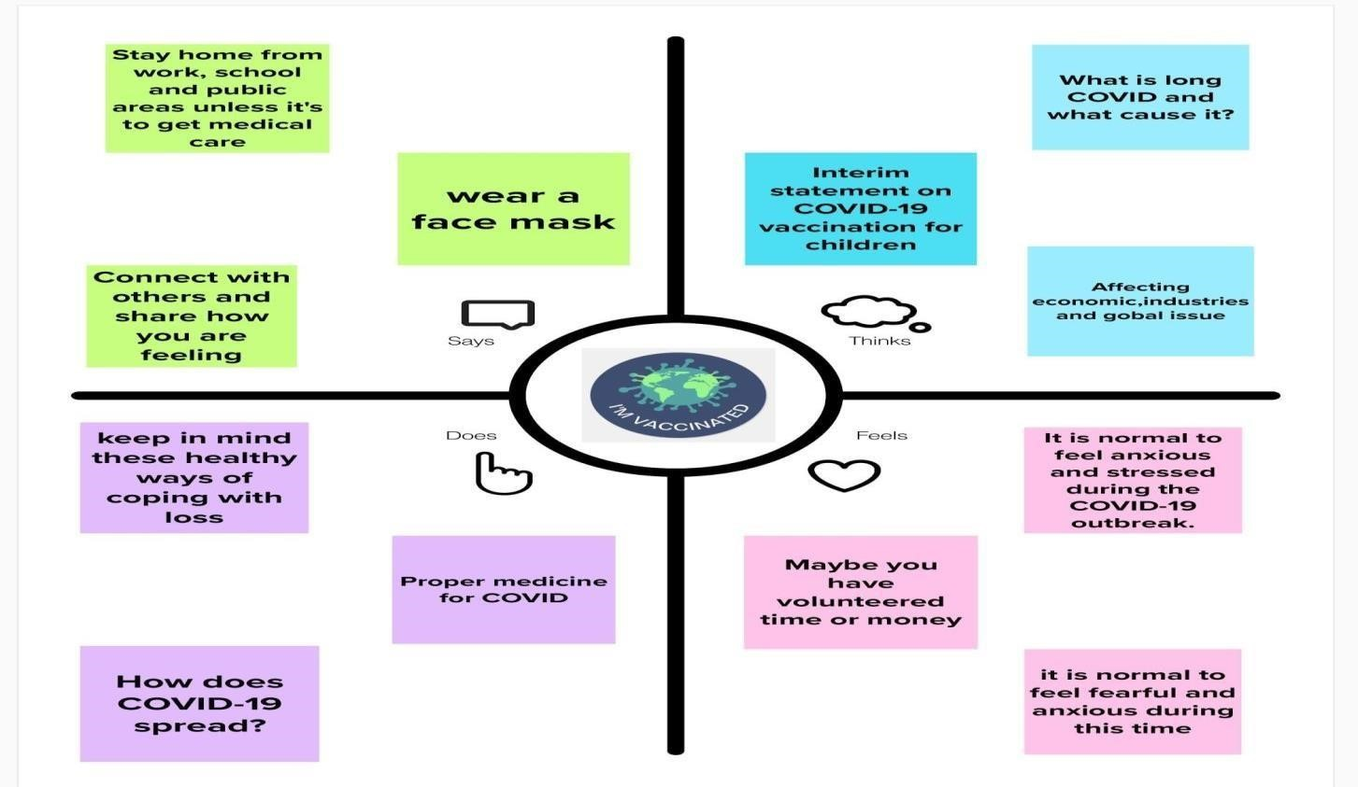

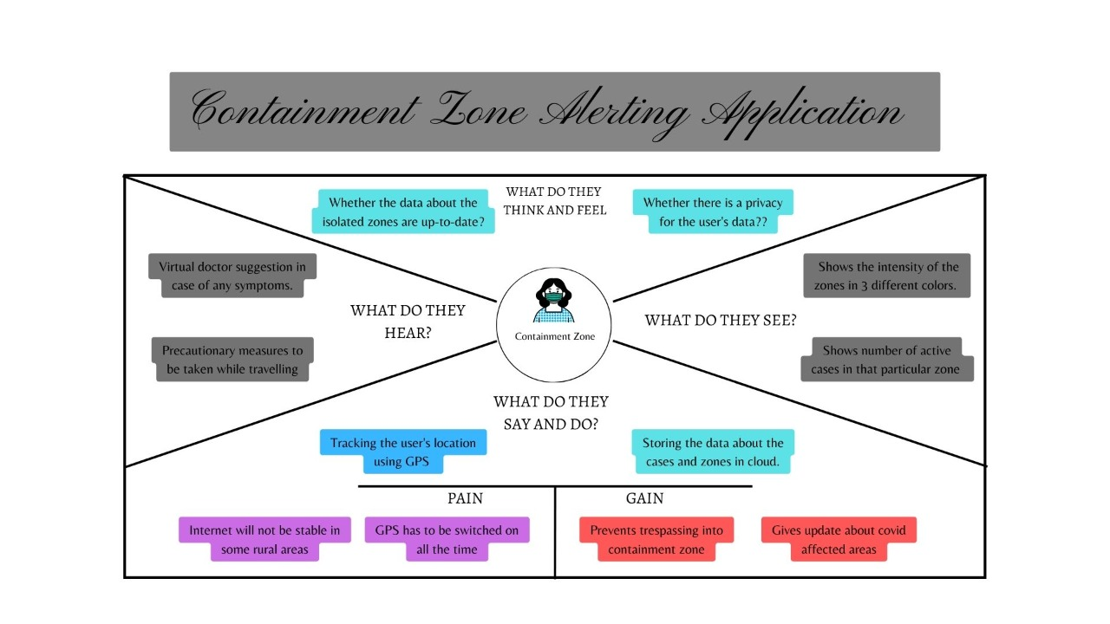

### 3.2 IDEATION & BRAINSTORMING

Brainstorming provides a free and open environment that encourages everyone within a team to participate in the creative thinking process that leads to problem solving. Prioritizing volume over value, out-of-the-box ideas are welcome and built upon, and all participants are encouraged to collaborate, helping each other develop a rich amount of creative solutions. Use this template in your own brainstorming sessions so your team can unleash their imagination and start shaping concepts even if you're not sitting in the same room.

BRAINSTROMING-IDEA GENERATION

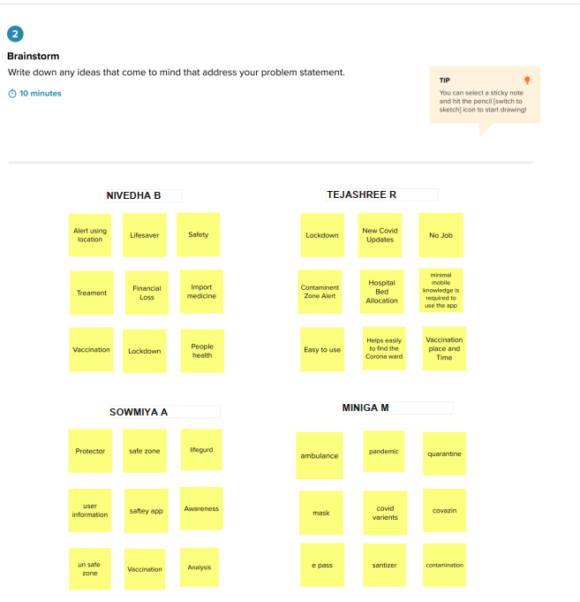

**3.3 PROPOSED SOLUTION**

|  |  |  |
| --- | --- | --- |
| **S.No.** | **Parameter** | **Description** |
| 1. | Problem Statement (Problem to be solved) | Development of an android application for viewing the covid containment zones and also the alerting the users not to enter the affected area using cloud and geofencing by sending notification. |
| 2. | Idea / Solution description | To create an easy-to-use android application to alert the user when they enter a Containment Zone. To provide accurate results and alerting at the exact time when they enter the zone. This is done with the help of integration of Google Maps. |
| 3. | Novelty / Uniqueness | * Development of an android application is necessary which can inform people of the Covid-19 containment zones and prevent trespassing into these zones. * Android Application updates the locations of the areas in a Google map which are identified to be the containment zones. * The application also notifies the users if they have entered a containment zone and upload the details of individual in online database. |
| 4. | Social Impact / Customer Satisfaction | The application saves people’s life from restricting them entering the Containment zone which saves them from catching the disease. Also shows precautionary measures when they entered the zones. |
| 5. | Business Model (Revenue Model) | Can tie up with people with normal and premium charges.   * The data that is derived can be used in Government sectors. * Can tie up the Government and get profit through that. |
| 6. | Scalability of the Solution | The application will be useful for all people from saving their life’s from catching the disease by alert |

**3.4 PROBLEM SOLUTION FIT**

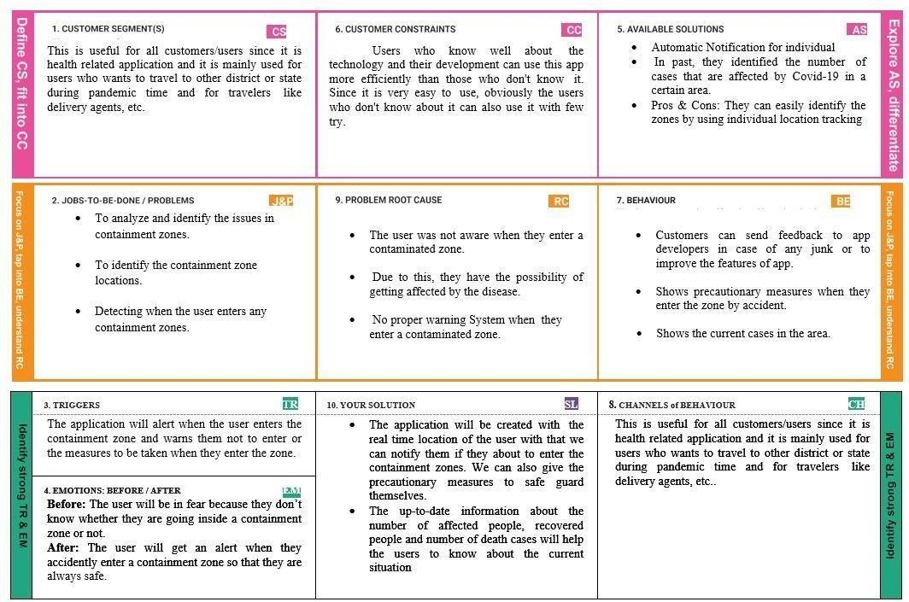

**CHAPTER 4**

## REQUIREMENT ANALYSIS

### 4.1 FUNCTIONAL REQUIREMENTS

|  |  |  |
| --- | --- | --- |
| **FR No.** | **Functional Requirement (Epic)** | **Sub Requirement (Story / Sub-Task)** |
| FR-1 | User Registration | It can be registered by valid Email id or Phone number. |
| FR-2 | User Confirmation | Verification code can received by registering email id or phone number. |
| FR-3 | Alert message via Notification | By user access of location while entered in the alerted area the notification are send by GPS tracking system and push the grids through mail id. |
| FR-4 | Show Infected Zones | Marked by Geofencing. |
| FR-5 | Track alternate routes | By Google map API or Google dependencies. |

### 4.2 NON-FUNCTIONAL REQUIREMENT

|  |  |  |
| --- | --- | --- |
| FR No. | Non-Functional Requirement | Description |
| NFR-1 | Usability | GUI is easier to interact with. |
| NFR-2 | Security | The data collected from the user will be stored securely. |
| NFR-3 | Reliability | The user can trust the results and navigate safely. |
| NFR-4 | Performance | Accurate results can be achieved due to real- time location sharing. |
| NFR-5 | Availability | Available if the network bandwidth of the user is of good range. |
| NFR-6 | Scalability | The application can be used from anywhere and can also be implemented for both mobile and web apps for the user to interact. |

## CHAPTER 5 PROJECT DESIGN

### 5.1 DATA FLOW DIAGRAMS

A Data Flow Diagram (DFD) is a traditional visual representation of the information flows within a system. A neat & clear DFD can depict the right amount of the system requirement graphically. It shows how data enters and leaves the system, what changes the information, and where data is stored.

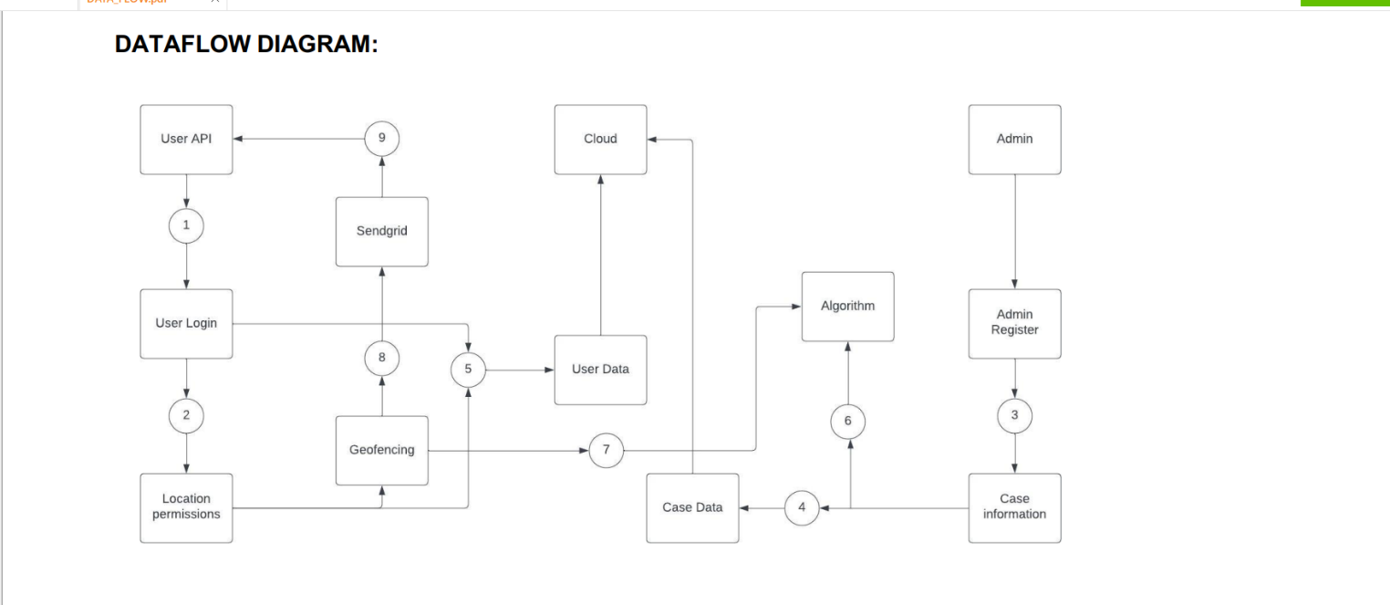

### 5.2 SOLUTION & TECHNICAL ARCHITECTURE

Solution architecture is a complex process – with many sub-processes – that bridges the gap between business problems and technology solutions. Its goals are to: o Find the best tech solution to solve existing business problems.

* Describe the structure, characteristics, behavior, and other aspects of the software to

project stakeholders. o Define features, development phases, and solution requirements.

* Provide specifications according to which the solution is defined, managed,

and delivered.

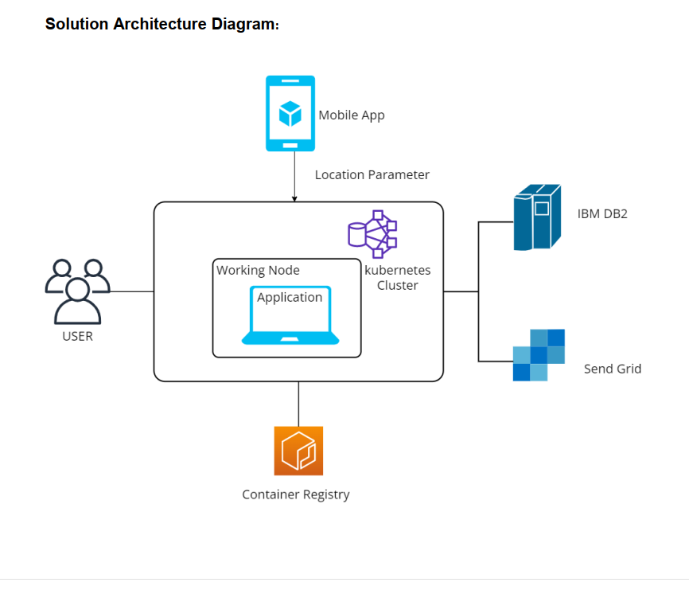

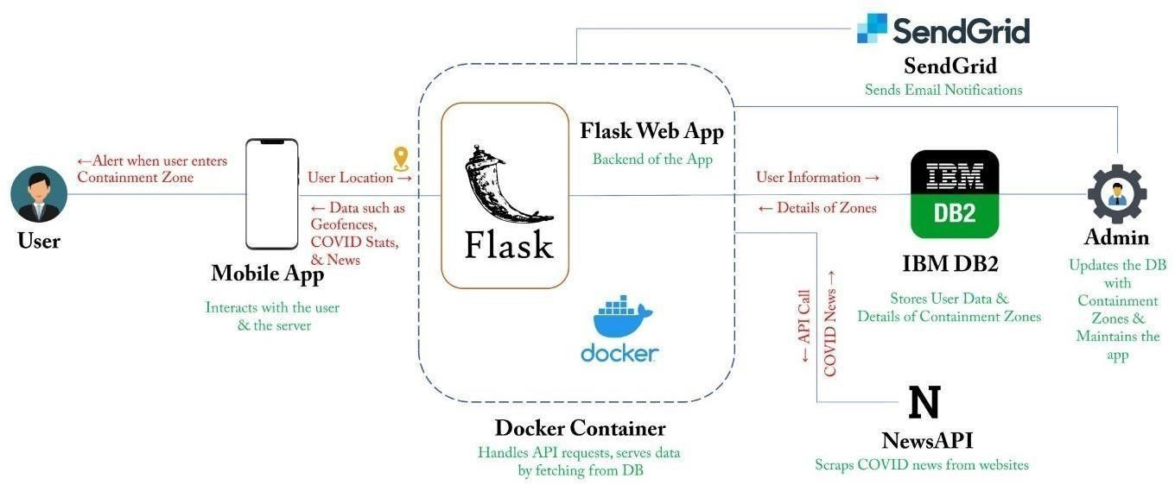

### 5.3 USER STORIES

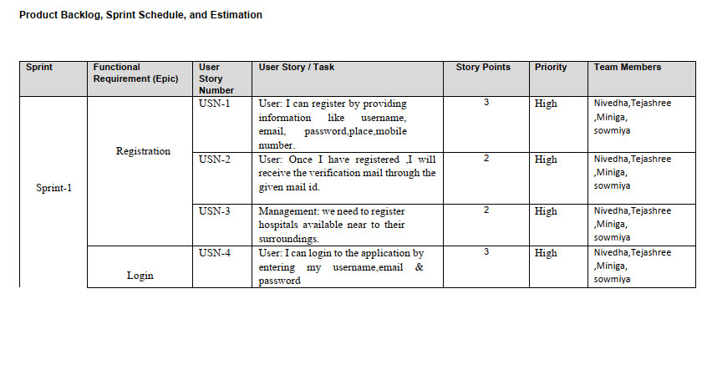

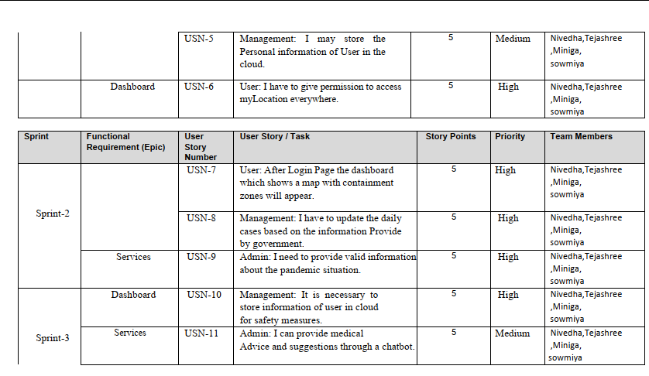

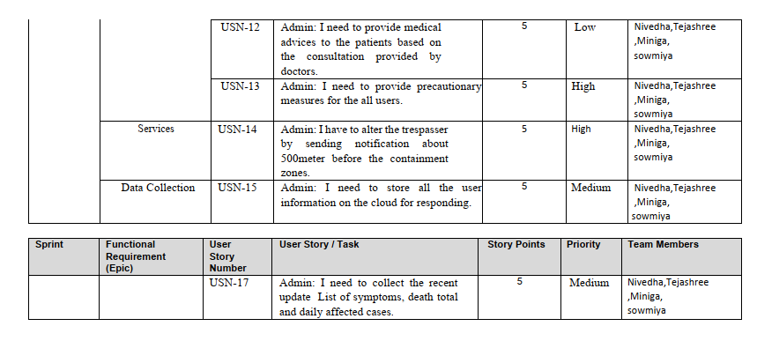

**CHAPTER 6**

**PROJECT PLANNING & SCHEDULING**

## SPRINT PLANNING & ESTIMATION

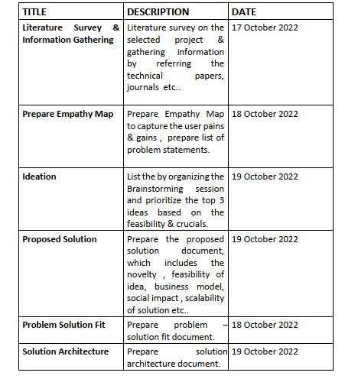

### 

### 6.1 SPRINT DELIVERY SCHEDULE

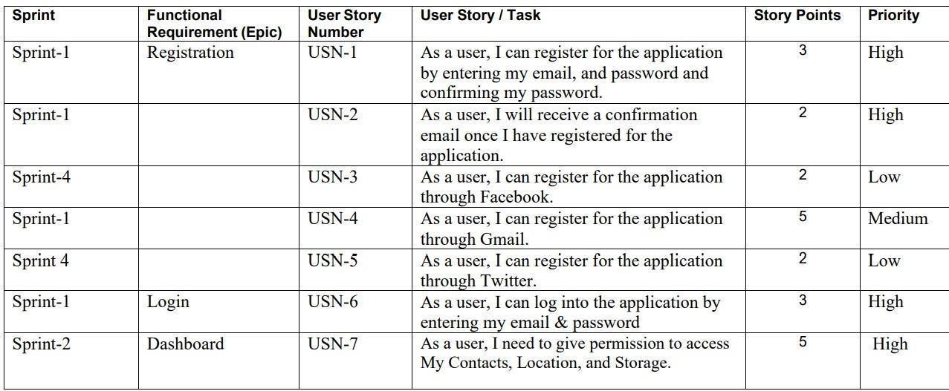

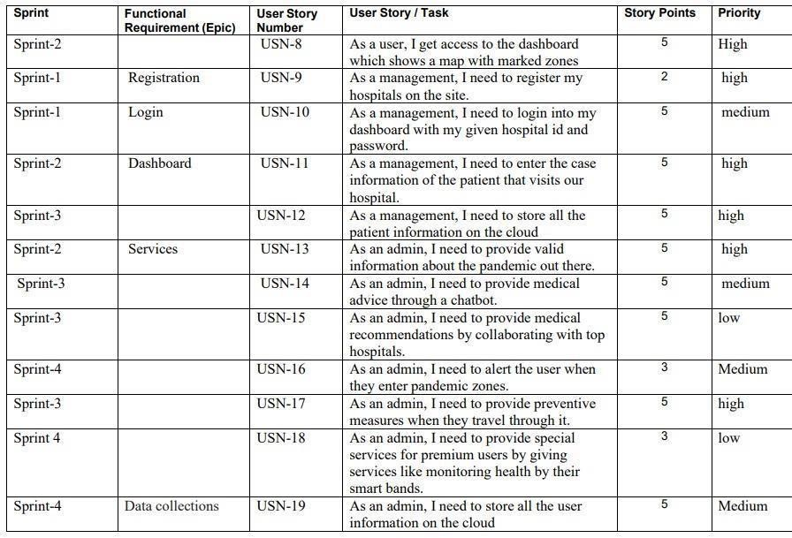

### 6.2 REPORTS FROM JIRA

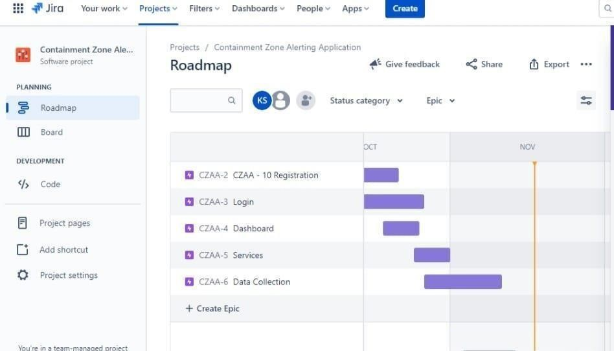

## CHAPTER 7 CODING & SOLUTIONING

### 7.1 FEATURE-1

In this page, the user can add the zone list, remove zone and add zone.

**CODING:**

<!DOCTYPE html>

<html lang="en">

<head>

</head>

<body>

<style> html, body {

overflow-x: hidden; overflow-y: hidden; height: 100%; width: 100%; position: absolute; background-color: black;

background-image: url('https://wallpapercave.com/wp/5KLTq1z.jpg'); background-repeat: no-repeat; background-size: cover; background-position: top; z-index: -2;

}

#display { color: white; font-size: 2.9em; top: 10px; border-bottom: thin solid; padding-bottom: 20px; opacity: 0.80; filter: alpha(opacity=80); /* For IE8 and earlier */

}

#date { color: white; font-size: 1.3em; font-family: Georgia, "Times New Roman", Times, serif; font-weight: normal; letter-spacing: 0.2em; opacity: 0.6; filter: alpha(opacity=60); /* For IE8 and earlier */

}

#footer { width: 100%; height: 40px; position: fixed; bottom: -1px; background-color: white; text-align: center; opacity: 0.5;

filter: alpha(opacity=50); /* For IE8 and earlier */

}

#line { width: 100%; bottom: 4em; position: fixed; border-bottom: solid white; padding: 15px; opacity: 0.5; filter: alpha(opacity=50); /* For IE8 and earlier */

}

.navbar { position: fixed; width: 100%; opacity: 0.6; filter: alpha(opacity=60); /* For IE8 and earlier */

}

.wrapper { background-color: red;

}

span {

border-radius: 100px; opacity: 0.75;

filter: alpha(opacity=75); /* For IE8 and earlier */

}

#content { height: 45em;

} p { max-width: 30em; color: white; font-family: "Adobe Caslon Pro", "Hoefler Text", Georgia, Garamond, Times, serif; letter-spacing:0.1em; text-align:center; margin: 40px auto;

text-transform: lowercase; line-height: 145%; font-size: 2em; font-variant: small-caps;

}

p :hover {

text-decoration: none;

}

.container { padding-top: 6em; text-align: center;

}

#b-nav { padding-bottom: 5em; position: fixed; width: 100%; bottom: 2em;

}

#b-nav ul { margin: 0; padding: 0.5em; list-style-type: none; text-align: center;

}

#b-nav ul li {

display: inline;

}

#b-nav ul li a { text-decoration: none; padding: .2em 1em; background-color: black; opacity: 0.4; filter: alpha(opacity=40); /* For IE8 and earlier */

}

.hold { width: 100%;

text-align: left;

}

#gen { outline: none; padding-top: 5px; text-decoration: none; opacity: 0.6; background-color: black; color: white; border: thin solid white; height: 40px; width: 100px; border-radius: 2px; transition: 0.5s; padding-bottom: 5px;

}

#gen:hover {

background-color: white; color: black; border: thin solid black; opacity: 0.8;

}

#gen a { text-decoration: none;

}

#date { color: white;

}

@media screen and (max-device-width: 800px)

and (max-device-height: 640px) and (-webkit-device-pixel-ratio: 2) and (orientation: portrait) {

p { font-size: 1em;

}

}

.fa-twitter { font-size: 30px !important; margin-left: 20px;

}

</style>

<link rel="stylesheet" type="text/css" href="https://cdnjs.cloudflare.com/ajax/libs/font- awesome/4.7.0/css/font-awesome.min.css">

<body onload="startTime(); startDate()">

<div class="container">

<div id="date"></div>

<div id="display"></div>

<div id="content">

<div class="logged"> </div></p>

<p id="quote">"SUCCESSFUL!"</p>

<a href="\table"><button type="button">ZONE LIST</button></a>

<a href="\addzone"><button type="button">ADD ZONE</button></a>

<a href="\removezone"><button type="button">REMOVE ZONE</button></a>

</div>

</div>

</body>

</html>

### 7.2 FEATURE-2

The users get alerted from entering the contaminated zone by geofencing the location and sending it as notification.

CODING:

<!DOCTYPE html>

<html lang="en">

<head>

</head>

<body>

<style> html, body { background: #333;

height: 100%; overflow: hidden; text-align: center;

}

.svg-wrapper { height: 60px; margin: 0 auto; position: relative;

transform: translateY(-50%); width: 320px;

}

.shape {

fill: transparent;

stroke-dasharray: 140 540;

stroke-dashoffset: -474; stroke-width: 8px; stroke: #19f6e8;

}

.text {

color: #fff00;

font-family: 'Roboto Condensed'; font-size: 22px; letter-spacing: 8px; line-height: 32px; position: relative; top: 300px;

}

@keyframes draw {

0% {

stroke-dasharray: 140 540;

stroke-dashoffset: -474; stroke-width: 8px;

}

100% {

stroke-dasharray: 760;

stroke-dashoffset: 0; stroke-width: 2px;

}

}

.svg-wrapper:hover .shape {

-webkit-animation: 0.5s draw linear forwards; animation: 0.5s draw linear forwards;

}

</style>

<form action="/loc" method="POST">

<br>

<br>

<input type="text" name="mail" class="input" id="mail" style="position: absolute; left: 20%; margin-left: 180px; width: 400px; height: 25px; background:grey ; border: 8px solid black; top:250px" placeholder="Enter email-id" required>

<div class="svg-wrapper">

<div>

<button type="submit" id="button" class="text" style="color:yellow; top:300px;background-color:#99ffff"><a href="/loc"> Notify me </a></button>

<p style="color:yellow;font-size:18px;top:300px">Enter email address to be notified on and

Click on Notify me to get alert message if you are in Containment Zone</p>

</div>

</form>

</div>

</body>

</html>

**7.3 DATABASE SCHEMA**

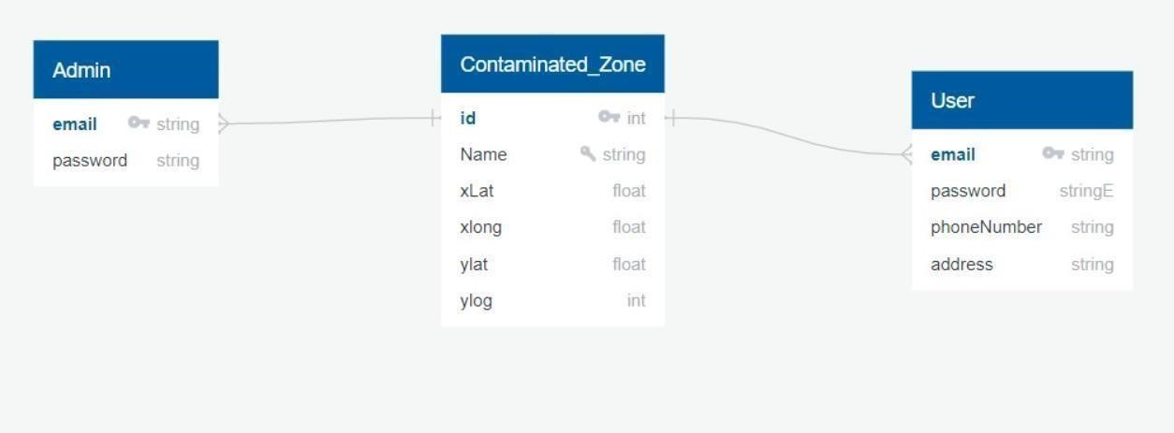

**CHAPTER 8**

## TESTING

### 8.1 TEST CASES

1. Login button click with wrong credentials entered.

1. Signup with already registered mail ID.

1. Signup with wrong form data entered.

1. Entering home page with logged out session.

1. Clicking home page buttons with logged out session.

1. Invalid data entered in change password page and requested for change in password.

### 8.2 USER ACCEPTANCE TESTING

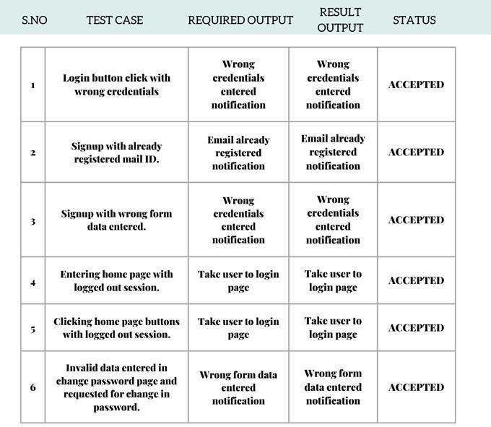

**CHAPTER 9**

## RESULTS

### 9.1 PERFORMANCE METRICS

This app service monitors the location and provide information about the contaminated zones near a particular user and send notification to the user. It displays the contaminated zone area by geofencing the particular location.

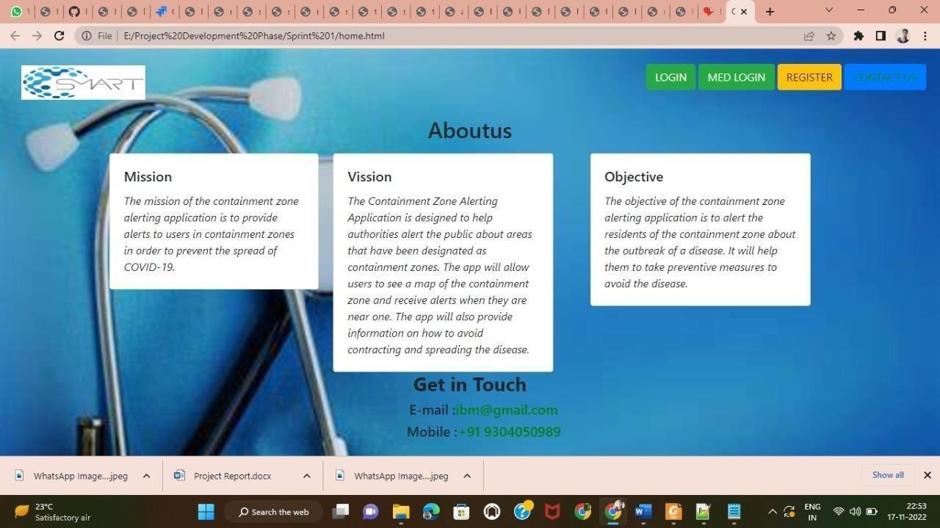

### Main Page

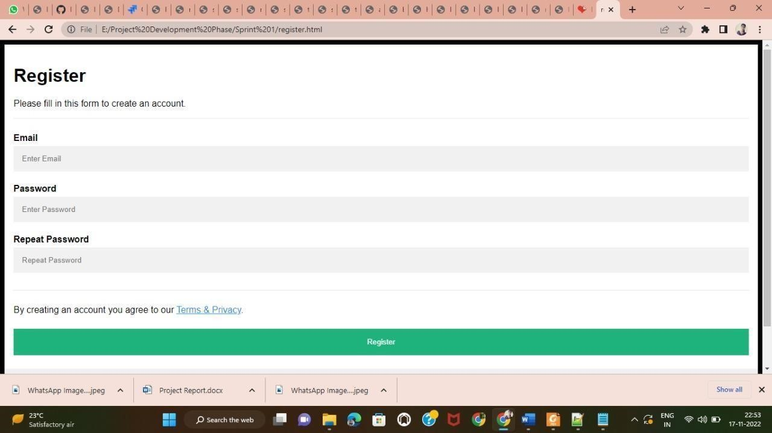

### Registration Form

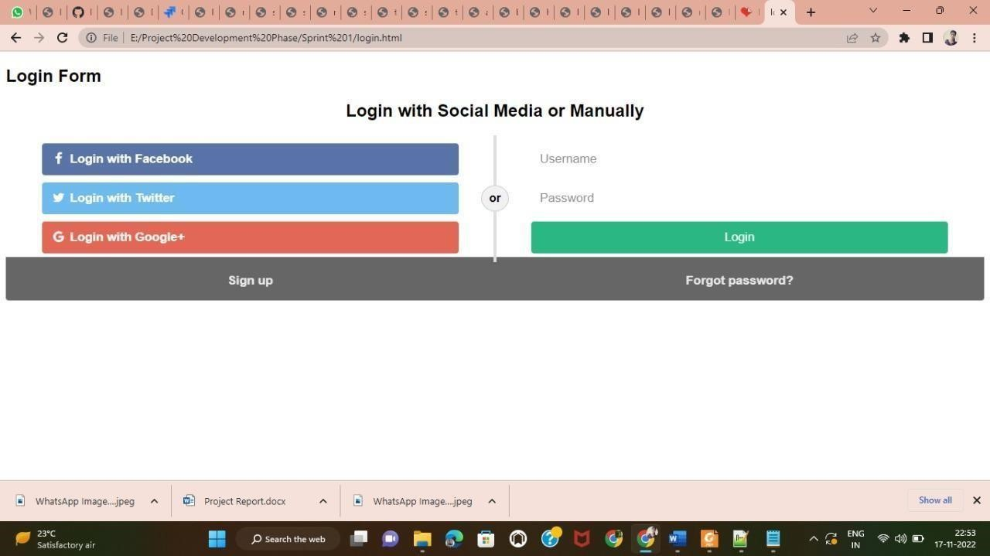

### Login Form

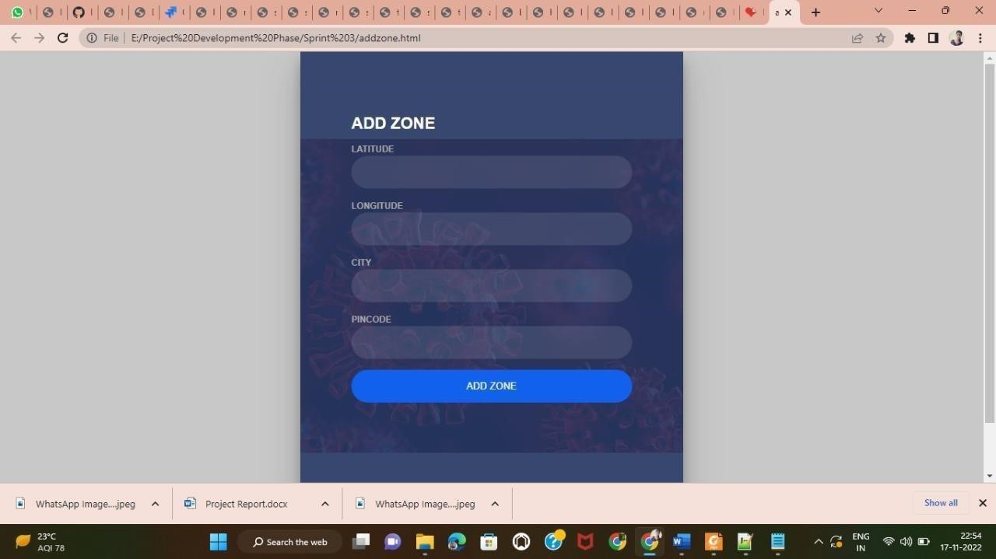

### Add Zone

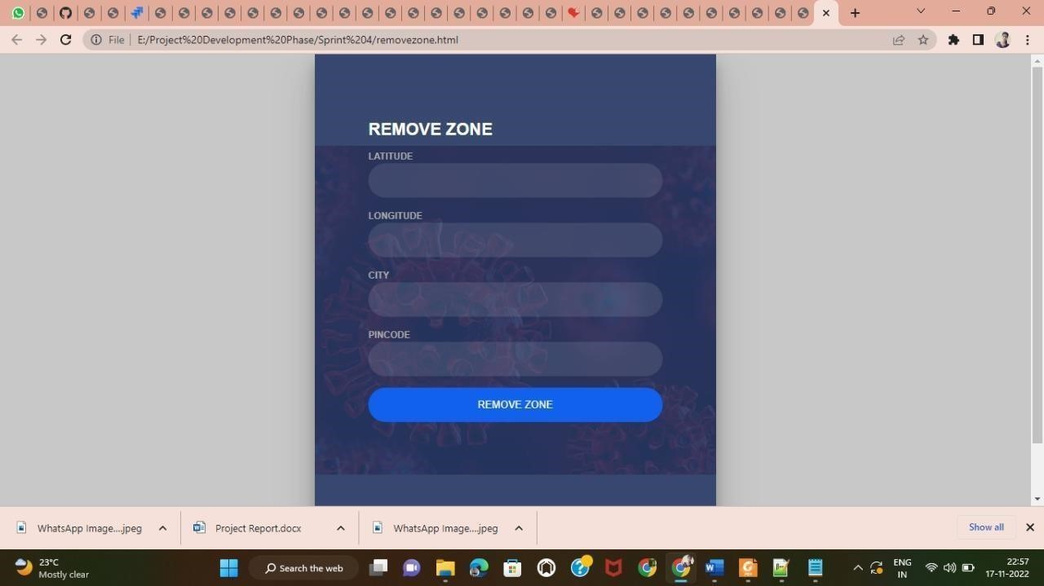

### Remove Zone

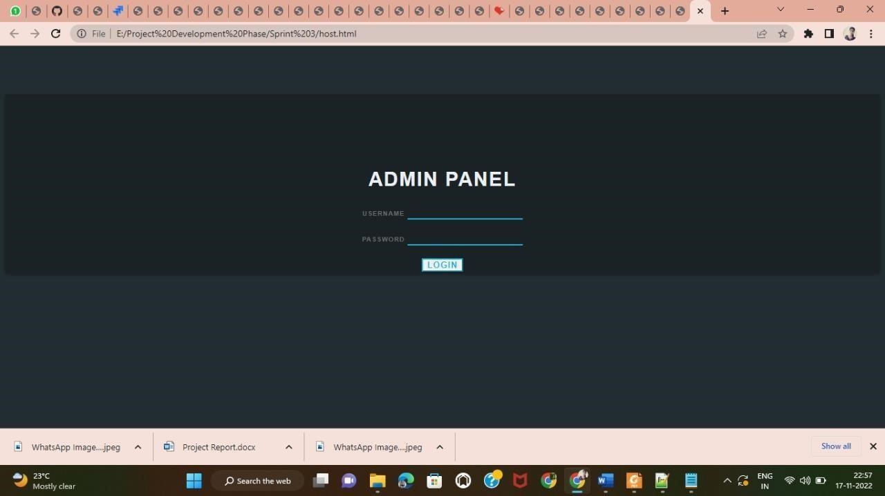

### Admin Login Page

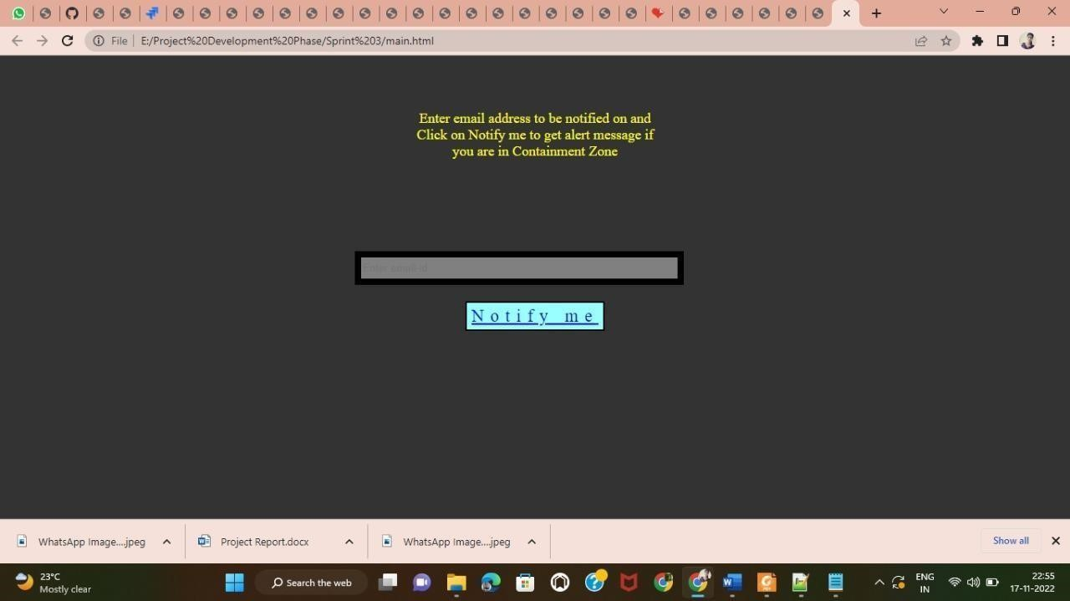

# Notify the Containment Zone

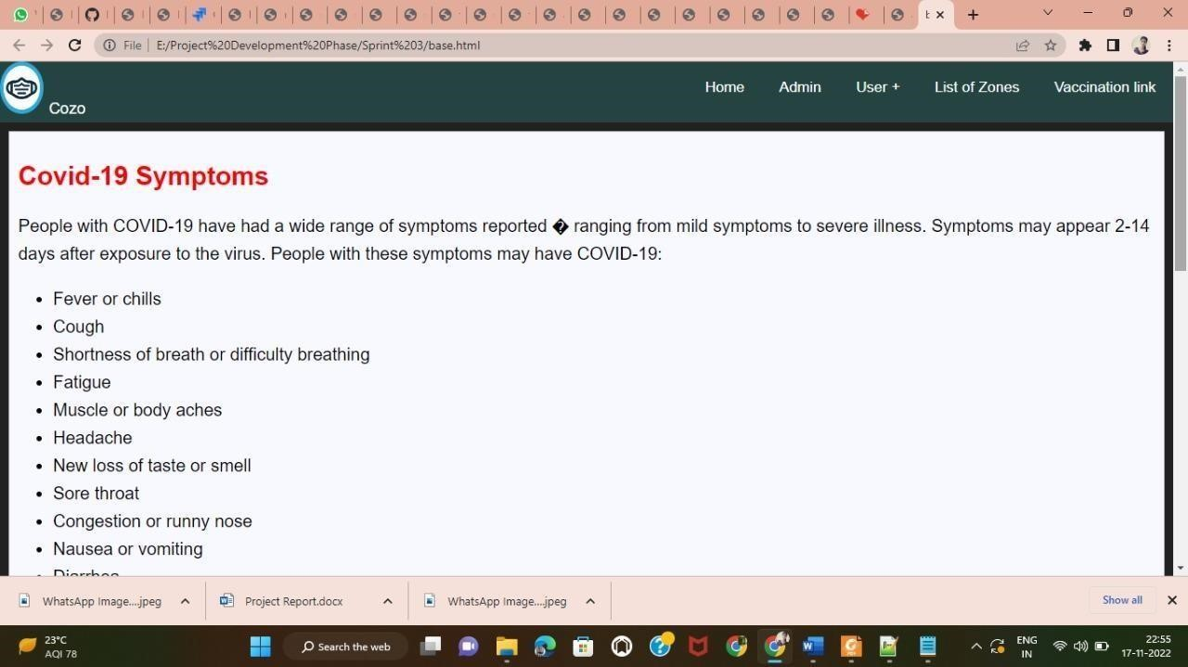

**About COVID-19**

## CHAPTER 10 ADVANTAGES & DISADVANTAGES

### 10.1 ADVANTAGES & DISADVANTAGES

The main advantage of containment zone alerting applications is that they can help to prevent the spread of diseases by alerting people to areas where there is a risk of infection. However, there are also some disadvantages to these applications, including the potential for false alarms and the possibility that people may ignore the warnings. This application is intended to provide information about containment zones in a particular region by alerting people, through continuous monitoring of an individual's location. Key benefits of the application are monitoring people's activity and alerting them of their safety movements.

## CHAPTER 11 CONCLUSION

We proposed a framework for identifying the contaminated zone areas and store it in database for future use. Then using the database, information is provided to the user about contaminated zone areas and alerting them by sending notification and geofencing the location. From the above information, it can be concluded that the Containment zone Alerting Application, in which we have successfully developed is a mobile application that sends alerts to users when they enter or exit a containment zone. The app uses GPS to track the user's location and sends an alert if the user enters or leaves a containment zone. The app also allows users to set up alerts for specific containment zones. It has successfully demonstrated the application. In this project, we alert users about the containment zone area by that they are aware and realize of high containment zone area.

## CHAPTER 12 FUTURE SCOPE

The application provides an efficient way of showing the identified COVID-19 containment zones to the users in a Google map. With the alarming increase of COVID19 affected cases throughout the world, this developed application can be employed as a tool for creating further social awareness among the people. This application further tracks the user's location and checks whether it is present in the list of identified containment zones. It sends separate notification alerts to the user on entering and exiting the containment areas. The developed android application further extracts the IMEI Number of the trespasser in the containment zones which can be useful to the local police to track and identify people who are frequently trespassing the containment zones. Thereby this application identifies the containment zones and highlights the need for taking further precautionary measures for combating COVID-

19. The application has been tested in various locations and has been found to yield accurate results. The application can be further used for many purposes like maritime and forest safety to prevent users from entering restricted areas.

## CHAPTER 13 APPENDIX

The Containment zone alerting application is a mobile application that sends alerts to users when they are in close proximity to a containment zone. The app uses the user's location to determine if they are in close proximity to a containment zone, and if so, sends an alert to the user. The app also allows users to view a map of containment zones in their area, and provides information on how to avoid contracting the virus.

## HOME.HTML

<!DOCTYPE html>

<html lang="en">

<style> body { background-image: url('E:/background.jpg'); background-repeat: no-repeat; background-attachment: fixed; background-size: cover;

}

a:link { color:green;

}

</style>

<head>

<meta charset="UTF-8">

<meta http-equiv="X-UA-Compatible" content="IE=edge">

<meta name="viewport" content="width=device-width, initial-scale=1.0">

<title>CZAA| HOME</title>

<meta charset="UTF-8">

<!-- favicon -->

<!-- <link rel="shortcut icon" href="/assets/img/favicon.ico" type="image/x-icon"> -->

<!-- <link rel="icon" href="/assets/img/favicon.ico" type="image/x-icon"> -->

<link rel="icon" type="image/jpg" sizes="16x16" href="E:\nature.jpg">

<!-- bootstrap css cdn -->

<link rel="stylesheet"

href="https://stackpath.bootstrapcdn.com/bootstrap/4.5.2/css/bootstrap.min.css" integrity="sha384-

JcKb8q3iqJ61gNV9KGb8thSsNjpSL0n8PARn9HuZOnIxN0hoP+VmmDGMN5t9UJ0Z" crossorigin="anonymous">

<link rel="stylesheet" href="https://cdnjs.cloudflare.com/ajax/libs/font- awesome/4.7.0/css/font-awesome.css">

<!-- css stylesheet -->

<link rel="stylesheet" href="css/style.css">

<!-- font styles cdn -->

<link rel="preconnect" href="https://fonts.gstatic.com">

<link href="https://fonts.googleapis.com/css2?family=Alegreya&display=swap" rel="stylesheet">

<link href="[https://fonts.googleapis.com/css2?family=Alegreya:wght@600&display=swap"](https://fonts.googleapis.com/css2?family=Alegreya%3Awght%40600&display=swap) rel="stylesheet">

</head>

<body>

<!-- bootstrap navbar -->

<nav class="navbar sticky-top navbar-expand-lg navbar-dark">

<div class="container-fluid">

<a class="main-logo-img mt-3" href="#"><img src="E:/smart intern.jpg" alt="sheep- logo" height="50px" width="180px">

<!-- <a class="navbar-brand" href="index.html">JobPortal</a> -->

</a>

<div class="row donate-sponsor">

<a type="button" class="btn btn-success mr-1" id="donate" href="login.html">LOGIN</a>

<a type="button" class="btn btn-success mr-1" id="donate"

href="medreg.html">MED LOGIN</a>

<a type="button" class="btn btn-warning mr-1" id="sponsor" href="register.html">REGISTER</a>

<a type="button" class="btn btn-primary mr-1" id="sponsor" href="contact.html">CONTACT US</a>

</div>

</div>

</nav>

<!-- navbar ends -->

<!-- what we focus on -->

<section class="our-focus">

<div class="container">

<h2 class="text-center mt-3">Aboutus</h2>

<div class="row ml-3 mt-3">

<div class="col-lg-3 mr-5" id="focus-first">

<div class="card" style="width: 19rem;">

<div class="card-body">

<h5 class="card-title">Mission</h5>

<p class="card-text"><i>The mission of the containment zone alerting

application is to provide alerts to users in containment zones in order to prevent the spread of COVID-19.</i></p>

</div>

</div>

</div>

<div class="col-lg-3 mr-5" id="focus-second">

<div class="card" style="width: 20rem;">

<div class="card-body">

<h5 class="card-title">Vission</h5>

<p class="card-text"><i>The Containment Zone Alerting Application is

designed to help authorities alert the public about areas that have been designated as containment zones. The app will allow users to see a map of the containment zone and receive alerts when they are near one. The app will also provide information on how to avoid contracting and spreading the disease.</i></p>

</div>

</div>

</div>

<div class="col-lg-3 ml-5" id="focus-third">

<div class="card" style="width: 20rem;">

<div class="card-body">

<h5 class="card-title">Objective</h5>

<p class="card-text"><i>The objective of the containment zone alerting

application is to alert the residents of the containment zone about the outbreak of a disease. It will help them to take preventive measures to avoid the disease.</i></p>

</div>

</div>

</div>

</div>

</div>

</section>

<footer>

<center>

<div class="col-xs-2 col-md-4">

<h3> <b> Get in Touch <b> </h3>

<ul class="footer-links">

<h5> E-mail :<a href="mailto:test@gmail.com">ibm@gmail.com</a></h5>

<h5> Mobile :<a href="9304050989">+91 9304050989</a></h5>

</ul>

</div>

</center>

</footer>

</body>

</html>

## LOGIN.HTML

<!DOCTYPE html>

<html>

<head>

<meta name="viewport" content="width=device-width, initial-scale=1">

<link rel="stylesheet" href="https://cdnjs.cloudflare.com/ajax/libs/font- awesome/4.7.0/css/font-awesome.min.css">

<style> body {

font-family: Arial, Helvetica, sans-serif;

}

* { box-sizing: border-box;

}

/* style the container */

.container { position: relative; border-radius: 5px; background-color: #f2f2f2; padding: 20px 0 30px 0;

}

/* style inputs and link buttons */ input,

.btn { width: 100%; padding: 12px; border: none; border-radius: 4px; margin: 5px 0; opacity: 0.85; display: inline-block; font-size: 17px; line-height: 20px;

text-decoration: none; /* remove underline from anchors */

}

input:hover,

.btn:hover { opacity: 1;

}

/* add appropriate colors to fb, twitter and google buttons */

.fb {

background-color: #3B5998; color: white;

}

.twitter {

background-color: #55ACEE; color: white;

}

.google { background-color: #dd4b39; color: white;

}

/* style the submit button */

input[type=submit] {

background-color: #04AA6D; color: white; cursor: pointer;

}

input[type=submit]:hover {

background-color: #45a049;

}

/* Two-column layout */

.col {

float: left;

width: 50%; margin: auto; padding: 0 50px; margin-top: 6px;

}

/* Clear floats after the columns */

.row:after { content: ""; display: table; clear: both;

}

/* vertical line */

.vl { position: absolute; left: 50%; transform: translate(-50%); border: 2px solid #ddd; height: 175px;

}

/* text inside the vertical line */

.vl-innertext { position: absolute; top: 50%;

transform: translate(-50%, -50%); background-color: #f1f1f1; border: 1px solid #ccc; border-radius: 50%; padding: 8px 10px;

}

/* hide some text on medium and large screens */

.hide-md-lg { display: none;

}

/* bottom container */

.bottom-container { text-align: center; background-color: #666; border-radius: 0px 0px 4px 4px;

}

/* Responsive layout - when the screen is less than 650px wide, make the two columns stack on top of each other instead of next to each other */

@media screen and (max-width: 650px) {

.col { width: 100%; margin-top: 0;

}

/* hide the vertical line */

.vl { display: none;

}

/* show the hidden text on small screens */

.hide-md-lg { display: block; text-align: center;

}

}

</style>

</head>

<body>

<h2><b>Login Form<b></h2

<div class="container">

<form action="/action_page.php">

<div class="row">

<h2 style="text-align:center">Login with Social Media or Manually</h2>

<div class="vl">

<span class="vl-innertext">or</span>

</div>

<div class="col">

<a href="#" class="fb btn">

<i class="fa fa-facebook fa-fw"></i> Login with Facebook </a>

<a href="#" class="twitter btn">

<i class="fa fa-twitter fa-fw"></i> Login with Twitter

</a>

<a href="#" class="google btn"><i class="fa fa-google fa-fw">

</i> Login with Google+

</a>

</div>

<div class="col">

<div class="hide-md-lg">

<p>Or sign in manually:</p>

</div>

<input type="text" name="username" placeholder="Username" required>

<input type="password" name="password" placeholder="Password" required>

<input type="submit" value="Login">

</div>

</div>

</form>

</div>

<div class="bottom-container">

<div class="row">

<div class="col">

<a href="#" style="color:white" class="btn">Sign up</a>

</div>

<div class="col">

<a href="#" style="color:white" class="btn">Forgot password?</a> </div>

</div>

</div>

</body>

</html>

## REGISTER.HTML

<!DOCTYPE html>

<html>

<head>

<meta name="viewport" content="width=device-width, initial-scale=1">

<style> body {

font-family: Arial, Helvetica, sans-serif; background-color: black;

}

* { box-sizing: border-box;

}

/* Add padding to containers */

.container { padding: 16px; background-color: white;

}

/* Full-width input fields */ input[type=text], input[type=password] { width: 100%; padding: 15px; margin: 5px 0 22px 0; display: inline-block; border: none; background: #f1f1f1;

}

input[type=text]:focus, input[type=password]:focus {

background-color: #ddd; outline: none;

}

/* Overwrite default styles of hr */ hr {

border: 1px solid #f1f1f1; margin-bottom: 25px;

}

/* Set a style for the submit button */

.registerbtn { background-color: #04AA6D; color: white; padding: 16px 20px; margin: 8px 0; border: none; cursor: pointer; width: 100%; opacity: 0.9;

}

.registerbtn:hover { opacity: 1;

}

/* Add a blue text color to links */ a { color: dodgerblue;

}

/* Set a grey background color and center the text of the "sign in" section */

.signin { background-color: #f1f1f1; text-align: center;

}

</style>

</head>

<body>

<form action="/action_page.php">

<div class="container">

<h1>Register</h1>

<p>Please fill in this form to create an account.</p>

<hr>

<label for="email"><b>Email</b></label>

<input type="text" placeholder="Enter Email" name="email" id="email" required>

<label for="psw"><b>Password</b></label>

<input type="password" placeholder="Enter Password" name="psw" id="psw" required>

<label for="psw-repeat"><b>Repeat Password</b></label>

<input type="password" placeholder="Repeat Password" name="psw-repeat" id="psw- repeat" required>

<hr>

<p>By creating an account you agree to our <a href="#">Terms & Privacy</a>.</p>

<button type="submit" class="registerbtn">Register</button>

</div>

<div class="container signin">

<p>Already have an account? <a href="#">Sign in</a>.</p> </div>

</form>

</body>

</html>

**GITHUB ACCOUNT:** **https://github.com/IBM-EPBL/IBM-Project-34567-1660238537**

**DEMO VIDEO LINK:**<https://jira.be/grvTWk41b8A>